**DOS COMMANDS**

**dir**

The command lists the contents of a directory. The *dir* command typed by itself, displays the disk's volume label and serial number; one directory or filename per line, including the filename extension, the file size in bytes, and the date and time the file was last modified; and the total number of files listed, their cumulative size, and the free space (in bytes) remaining on the disk.

**dir [drive:][path][filename][parameters]**

Most commonly used parameters of *dir* include:

**/W**: Displays the listing in wide format, with as many as five filenames or directory names on each line.

**/P**: Pause at every page.

**/S**: Also look in subdirectories.

**/Axx**: Display files with the specified attributes only.

Possible attributes for the A parameter are D (directories), R (read-only files), H (hidden files), A (files/directories with the archive bit on), and S (system files). The prefix - negates an attribute; attributes can be combined (e.g. /A:DA means directories with the archive bit on).

**cd**

Change current working directory. It displays the current working directory when used without a path parameter.

**cd**: displays the current working directory on the current drive.

**cd directory**: changes the working directory on the current drive to *directory*.

**cd..**: changes the working directory to the parent directory (up one directory level).

**cd\**: changes the working directory to the root (top level) directory of the current drive.

**mkdir**

It is also written as **md**. This command makes a new directory. The parent of the directory specified will be created if it does not already exist.

**md directory**

**rmdir**

It is also written as rd. Remove a directory, which by default must be empty of files for the command to succeed (the /s flag removes this restriction).

**rd directory**

**copy**

Copies files from one location to another. The destination defaults to the current directory. If multiple source files are indicated, the destination must be a directory, or an error will result.

**copy from [source\filename] to [destination\folder]**

* **copy *file* con** outputs *file* to the screen ("console"), which can also be done using type *file*.
* **copy con *file*** takes the text typed into the console and puts it into *file*, stopping when EOF (Ctrl+Z) is typed.
* Files may be concatenated using +. copy *file1*+*file2* *file_cat* will concatenate the files and output them as *file_cat*.
* There are two switches to modify the command's behaviour, /a (text mode, the default) and /b (binary mode). In text mode, copy will stop when it reaches the EOF character; in binary mode, the files will be concatenated in their entirety, ignoring EOF characters.

**ren**

This command renames a file. Unlike the move command, this command cannot be used to rename subdirectories, or rename files across drives.

**ren filename newname**

You can rename files in another directory by using the PATH parameter:

**ren [path] [filename] [newfilename]**

On DOS with long filename support, care must be taken when directories have spaces in their names like "Documents and Settings". In these cases double-quotes are used to enclose them:

ren C:\”Documents and Settings”\”All Users”\Desktop file1.txt file2.txt

Mass renames can be accomplished by the use of wildcards. For example, the following command will change the extension of all files in the current directory which currently have the extension htm to html:

ren *.htm *.html

**echo**

Prints its own arguments back out to the DOS equivalent of the standard output stream. Usually, this means directly to the screen, but the output of *echo* can be redirected like any other command. Often used in batch files to print text out to the user.

echo this is text Outputs ‘this is text’

echo . Outputs a blank line

Echo can be used to write to files directly from the console, by redirecting the output stream:

**echo text > filename**

Echo can also be used to append to files directly from the console, again by redirecting the output stream:

**echo text >> filename**

**date and time**

Display and set the time and date.

**date**

**time**

When these commands are called from the command line or a batch file, they will display the time or date and wait for the user to type a new time or date and press RETURN. The command 'time /t' will bypass asking the user to reset the time.

**ver**

An internal DOS command, that reports the DOS version presently running.

**vol**

An internal DOS command that, displays a disk's volume label.

**pause**

Suspends processing of a batch program and displays the message 'Press any key to continue. . .'.

**cls**

Clears the screen.

**tree**

The command shows the directory tree of the current directory.

**tree [options] [directory]**

Options:

**/F:** Displays the names of the files in each folder.

**/A:** Use ASCII instead of the extended characters.

**/?:** Shows the help.

**chkdsk**

The command verifies a storage volume (hard disk, partition, floppy disk, flash drive, etc) for file system integrity.

**chkdsk volume letter: [[path] filename] [/F] [/P] [/R] [/X]**

Options:

**/F**: Fixes errors on the volume (without /F , chkdsk only detects errors).

**/P**: Forces a full verification.

**/R**: Searches for defective sectors and recovers legible information (applies /F).

**/X**: Unmounts the volume before processing if needed.

**attrib**

The command changes or views the attributes of one or more files. It defaults to displaying the attributes of all files in the current directory.

**attrib [+R|-R] [+A|-A] [+S|-S] [+H|-H] [drive:] [path] [filename] [/S[/D]]**

Options:

To add an attribute attach a '+' in front of it.

To remove an attribute attach a '-' in front of it.

Attributes include

**R** - Read-only

**A** - Archive

**S** - System

**H** - Hidden

**/D** - Process folders as well.

**/S** - Process matching files in the current folder and all subfolders.

**edit**

Starts the MS-DOS editor, a text editor used to create and edit ASCII text files.

**format**

Delete all the files on the disk and reformat it for MS-DOS.

**OUTPUT**

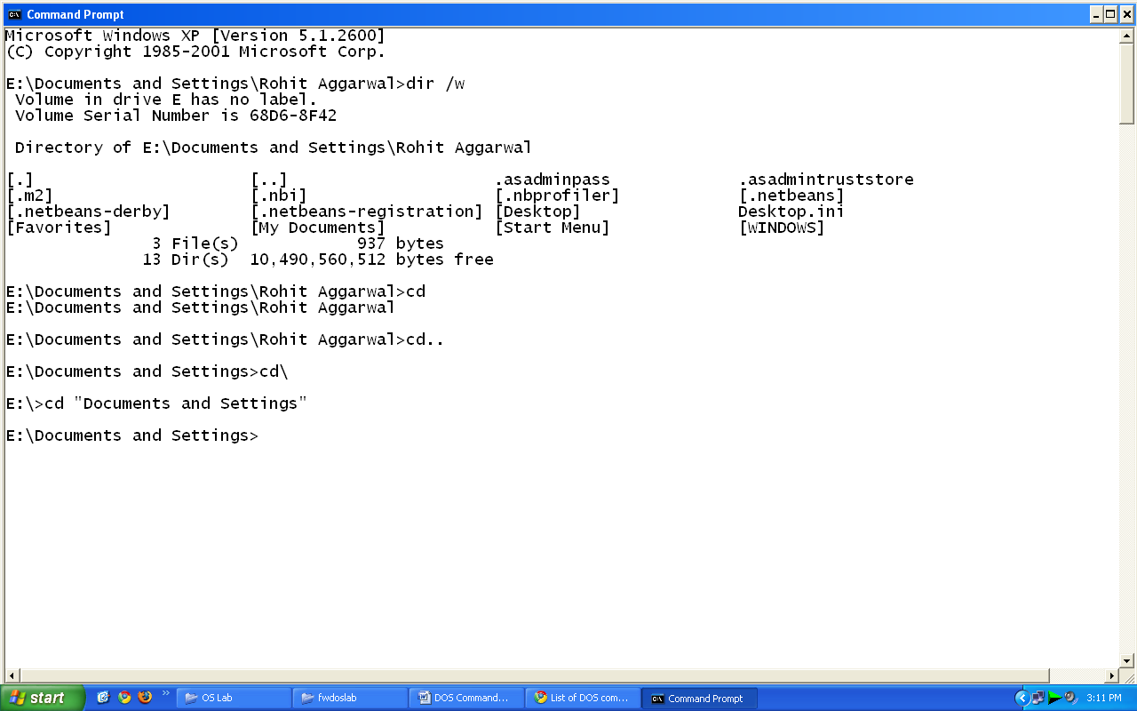

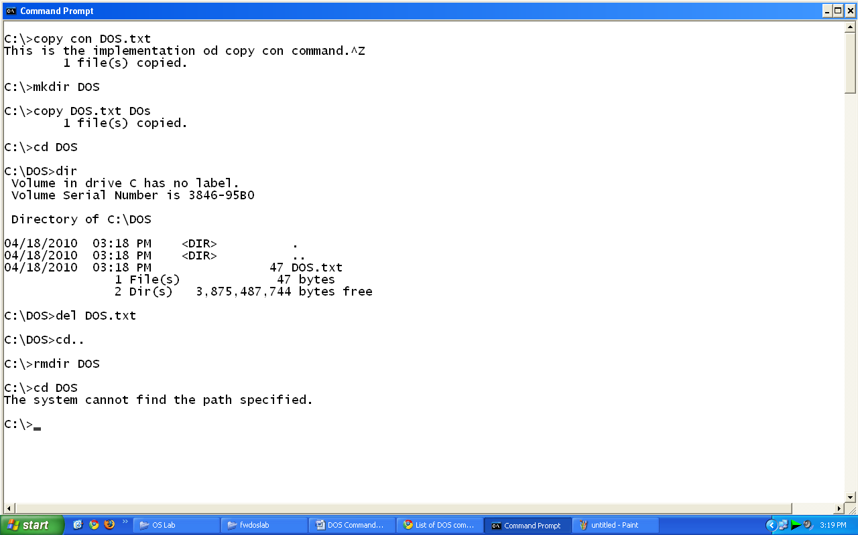

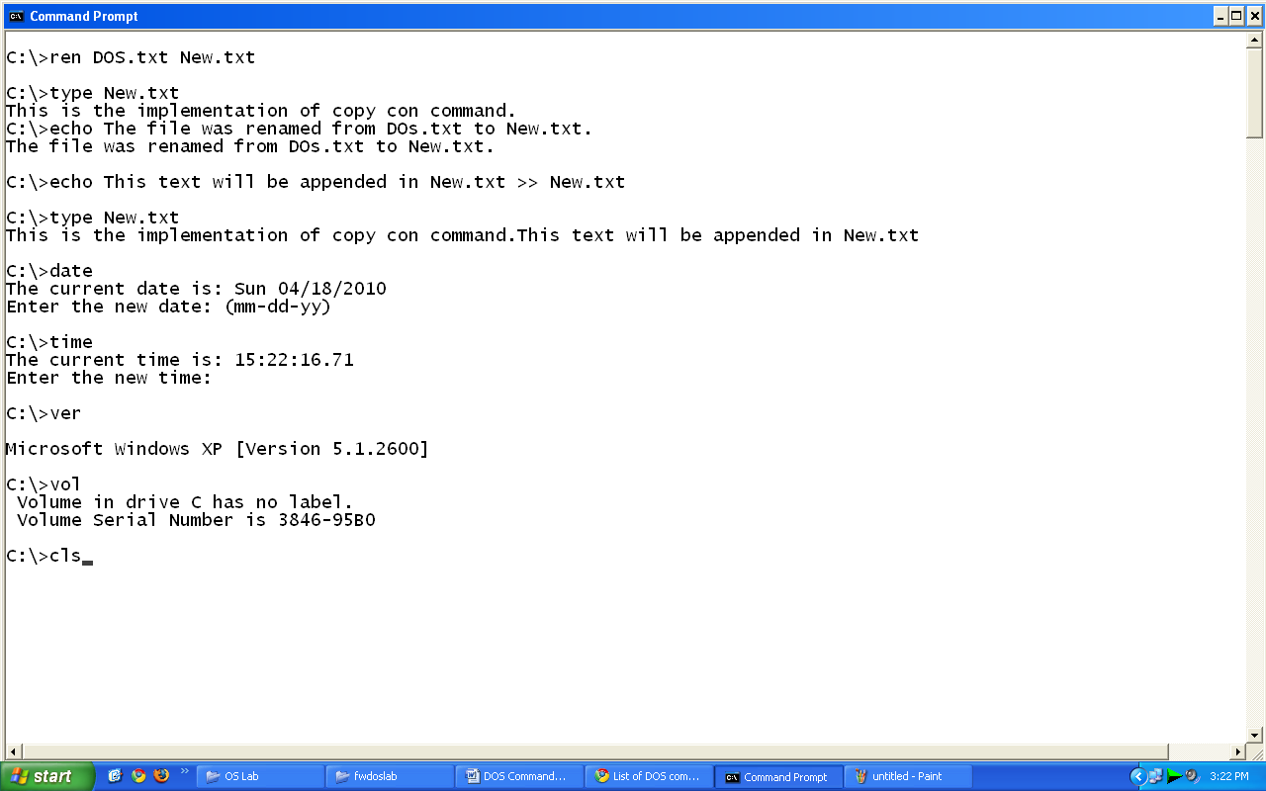

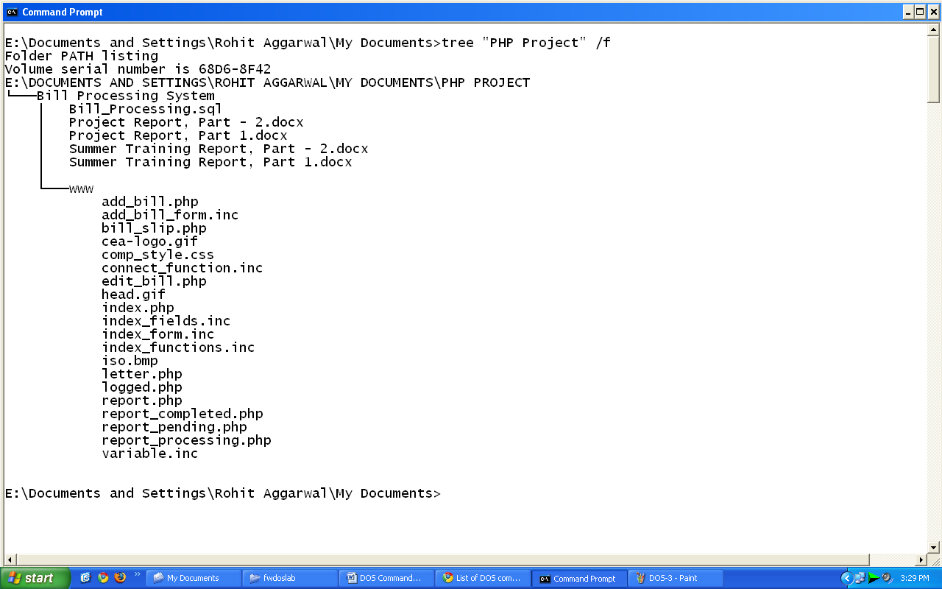

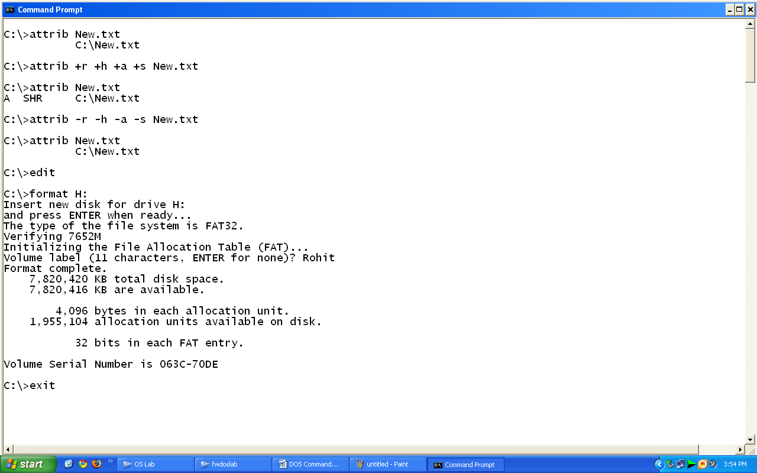

**Name : Rohit Aggarwal**

**Roll No. : 7CS-097**